**As You Like It**

Shakespeare in the Gardens

February 2024



**Auditions**

By video submission

Sunday 25 September – Monday 2 October, 2023

theothertheatrecompany.com.au

**Production Information:**

**Performance Dates** 16, 17 & 23, 24 February, 2024

**Rehearsals** Thursday, 7-9pm and Saturday, 2-5pm

**Director:** Pieta Swann – 0425 291 784

Running away from the royal court ruled by the tyrant Duke Frederick, cousins Rosalind and Celia and their clown Touchstone find solace in the Forest of Arden, but love and folly await them.

*As You Like It* is a light-hearted comedy that celebrates breaking free from expectations and the joy we find in being ourselves and finding love.

This production will use Shakespeare’s original language and characters, however, it has been adapted and shortened, so some characters and scenes have been omitted.

**Characters:**

**Rosalind**

Female: 20s-30s – 11 scenes

Clever and determined, the daughter of Duke Senior and cousin to Celia. She is stereotypically feminine at court, but is her true self when she runs away to the forest, dresses as a man.

**Orlando**

Male 20s-30s – 9 scenes

Well spoken, intelligent and brave, he is the youngest of the Rowland brothers and is pushed around by Oliver. He’s a hopeless romantic and writes poetry.

**Celia**

Female: 15-30s – 9 scenes

Fun-loving and positive child of Duke Frederick. She is devoted to her cousin, Rosalind, and can be a bit silly and dramatic at times.

**Duke Senior**

40+ - 3 scenes

Laid-back, nature-loving, fair & honest. They are the rightful but exiled duke; sibling to Duke Frederick; parent to Rosalind.

**Oliver**

Male 20s-40s – 5 scenes

Angry and manipulative, he conspires against his youngest brother Orlando, but finds redemption in the Forest of Arden.

**Jacques**

20s-50s – 6 scenes

Ridiculously melancholy, but likeable, he is an attendant of the exiled Duke Senior. ‘All the Worlds a Stage’ speech.

**Duke Frederick**

30+ - 4 scenes

Volatile and menacing, they are the usurping sibling of Duke Senior and parent to Celia. They are the villain due to the exile of Rosalind.

**Touchstone**

18+ - 6 scenes

A comedic, physical (and at times risqué) role as the jester from the court of Duke Frederick. They accompany Rosalind and Celia in their escape to the Forest of Arden. Comedic role great for physical character actors.

**Le Beau**

18+ - 3 scenes

Court gossip who lives for the drama and the sound of their own voice.

**Silvius**

Male: 18-25 – 6 scenes

A sweet, country type, who falls hard for Phebe and unsuccessfully tries to woo her.

**Phebe**

Female: 18-25 – 3 scenes

A simple country girl, who initially refuses Silvius until she realises that she has judged a book by its cover.

**Amiens**

18+ - 4 scenes

Joyful, talented singer & attendant to Duke Senior.

**Adam**

50+ - 5 scenes

Devoted, loyal, kind and wise servant to Orlando.

**Charles**

20+ - 2 scenes

A buff wrestler who is not very smart.

**Audrey**

Female: 18+ - 3 scenes

A simple-minded country girl who values honesty above looks.

**Audition Pieces:**

Auditionees are asked to prepare **2** of the following audition pieces, using the description of their **2** preferred characters as a guide for the delivery of each piece. Aim to show your acting range in these two short monologues.

Please note that not all characters are represented in the following audition pieces, simply choose the pieces that you can present using the characterisation notes provided in the character list for your chosen characters.

Piece 1:

I am no villain; I am the youngest son of Sir   
Rowland de Boyes; he was my father, and he is thrice  
A villain that says such a father begot villains.

Wert thou not my brother, I would not take this hand

From thy throat till this other hand pulled  
Out thy tongue for saying so: thou hast railed on thyself.

Piece 2:

Neither his daughter, if we judge by manners;

But yet indeed the younger is his daughter

The other is daughter to the banish’d duke,

And here detain’d by the usurping duke,

To keep his daughter company; whose loves

Are dearer than the natural bond of sisters.

But I can tell you that of late this duke

Hath ta’en displeasure ‘gainst the gentle niece,

Grounded upon no other argument

But that the people praiser her for her virtues’

And pity her for her good father’s sake:

Piece 3:

He'll go along o'er the wide world with me;

Leave me alone to woo him. Let's away,

And get our jewels and our wealth together,

Devise the fittest time and safest way

To hide us from pursuit that will be made

After my flight. Now go we in content

To liberty and not to banishment.

Piece :4

Not see him since? Sir, sir, that cannot be:

But were I not the better part made mercy,

I should not seek an absent argument

Of my revenge, thou present. But look to it:

Find out thy brother, wheresoe'er he is;

Seek him with candle; bring him dead or living

Within this twelvemonth, or turn thou no more

To seek a living in our territory.

Thy lands and all things that thou dost call thine

Worth seizure do we seize into our hands,

Till thou canst quit thee by thy brothers mouth

Of what we think against thee.

Piece 5:

O, that thou knew'st how I do love her!

No, thou canst not guess,

How many actions most ridiculous

Hast I been drawn to by thy fantasy?

A thousand that I have forgotten.

O, thou didst then ne'er love so heartily!

If thou remember'st not the slightest folly

That ever love did make thee run into,

Thou hast not loved:

Or if thou hast not sat as I do now,

Wearying thy hearer in thy mistress' praise,

Thou hast not loved:

O Phebe, Phebe, Phebe!

Piece 6:

All the world's a stage,

And all the men and women merely players:

They have their exits and their entrances;

And one man in his time plays many parts,

His acts being seven ages. At first the infant,

Mewling and puking in the nurse's arms.

And then the whining school-boy, with his satchel

And shining morning face, creeping like snail

Unwillingly to school. And then the lover,

Sighing like furnace, with a woeful ballad

Made to his mistress' eyebrow.

Piece 7:

Truly, shepherd, in respect of itself, it is a good

life, but in respect that it is a shepherd's life,

it is naught. In respect that it is solitary, I

like it very well; but in respect that it is

private, it is a very vile life. Now, in respect it

is in the fields, it pleaseth me well; but in

respect it is not in the court, it is tedious.

Hast any philosophy in thee, shepherd?

Piece 8:

There is none of my uncle's marks upon you: he

taught me how to know a man in love; in which cage

of rushes I am sure you are not prisoner.

A lean cheek, which you have not, a blue eye and

sunken, which you have not, an unquestionable

spirit, which you have not, a beard neglected,

which you have not; but I pardon you for that, for

simply your having in beard is a younger brother's

revenue: then your hose should be ungartered, your

bonnet unbanded, your sleeve unbuttoned, your shoe

untied and every thing about you demonstrating a

careless desolation; but you are no such man;

**Video and Submission Information**

Auditions for this production will be through video submissions. Auditionees are required to record their 2 prepared monologues and submit them, with a completed audition form, for the audition panel to review.

It is important that the audition panel is able to identify you and what roles you will consider for the production.

Please follow these suggestions when preparing your audition video:

* Introduce yourself in the video and state the characters for which you are auditioning.
* Ensure that your face can be clearly seen and your voice is audible before submitting your video.
* Take your time reading the Shakespearean language and showcase the character.

Once you have recorded and are happy with your audition:

* Select share by right-clicking on your file
* Update the access settings to ensure “anyone” on the audition panel can access the link and select “apply”
* Click on “copy link” and paste it into an email
* Attach your completed audition form to the email
* Send the email to [hello@totco.org.au](mailto:hello@totco.org.au) by 11.59 pm on Monday 2 October, 2023.

Please see below for step-by-step instructions on sharing your video submission.

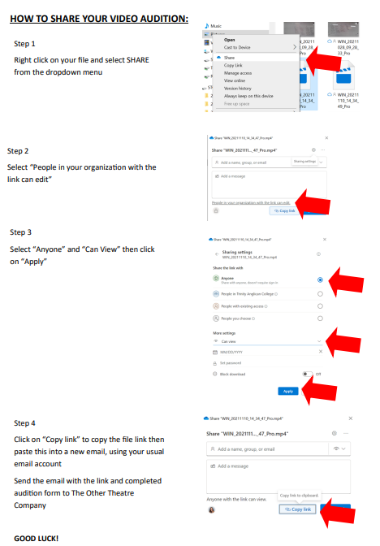

Audition video submission should be emailed to [hello@totco.org.au](mailto:hello@totco.org.au) along with your completed audition form by 11.59 pm on Monday 2 October, 2023.

If you have any issues, please contact the director, Pieta Swann, on 0425291784.